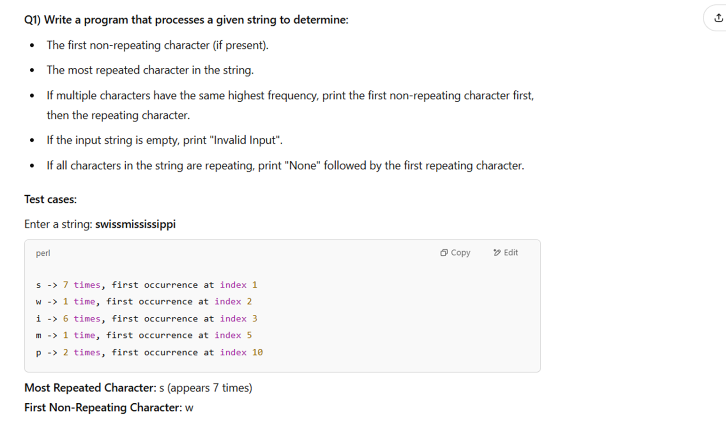

**from collections import Counter**

**s = input("Enter a string: ")**

**if not s:**

**print("Invalid Input")**

**else:**

**l = []**

**char_count_dict = Counter(s)**

**print(char_count_dict)**

**first_non_repeating_char =  0**

**Most_repeated_char_count = 0**

**for char in s:**

**if char_count_dict[char] == 1:**

**first_non_repeating_char = char**

**break**

**Most_repeated_char = max(char_count_dict, key = char_count_dict.get)**

**Most_repeated_char_count = char_count_dict[Most_repeated_char]**

**if first_non_repeating_char:**

**print("First Non reapteating char", first_non_repeating_char)**

**else:**

**for char in s:**

**if char_count_dict[char]> 1:**

**print("None")**

**break**

**print("Most Repeated Char", Most_repeated_char, "(", Most_repeated_char_count,")")**

Q2.Write a program that continuously takes user input for the following details:

* Income (amount earned).
* Type of Material (category of expenditure).
* Expenditure on that Material (amount spent).

The input process continues until the user enters “done”.

After input completion, the program should:

* Display the total income.
* Calculate and display the total savings (Income – Total Expenditure).
* List where the money was spent along with respective expenditure.

